Connected Personal Wellness

Techsoft
- Use Case Overview
Tuberculosis, caused by Mycobacterium tuberculosis(M.TB) bacteria is one of the most prevalent and serious infectious diseases worldwide. In 2015, there were an estimated 10.4 million new (incident) TB cases worldwide and 1.8 million died from the disease .Over 95% of TB deaths occur in low- and middle-income countries. Diagnosis of TB in developing world is very challenging due to the limited suitability of currently available techniques under tropical field conditions. It has been reported that 40-50% of TB cases remain undetected due to absence of TB bacilli in sputum. The rapid diagnosis and treatment of infectors is considered crucial for the effective control of TB because one patient is known to transmit the disease to 12–15 people/year on average through respiratory tract infection. M.TB is a slowly growing Mycobacterium that takes around six to eight weeks to be detected via sensitive culture methods. There is also hardly any clinical symptom at an early stage of infection by the emergence of multiple drug resistant (MDR) strains. Thus we are presenting an idea about a piezoelectric quartz crystal sensor which can detect the antigens of TB in just few hours. Therefore the main goal behind this used case proposal is to make a person aware about the presence of TB bacteria inside the body as fast as possible.
- Use Case Description

Abstract:
A biochip is a collection of a miniaturized test arrays arranged on a solid substrate that permits many tests to be performed at the same time in order to get high throughput and speed. The standard size of a biochip is 11.5 mm long. It is inserted via syringe into the veins. As the biosensor we have used piezoelectric quartz crystal sensor(PQC), which uses the piezoelectric effect to detect change in mass and convert it into quantifiable electrical signals. It has two components: a receptor and a detector. The receptor is responsible for the selectivity of sensor. Example includes enzymes, antibodies and lipid layers. The receptor of PQC consists of an antibody which will only catch the antigens of M.TB but will ignore all other blood components.
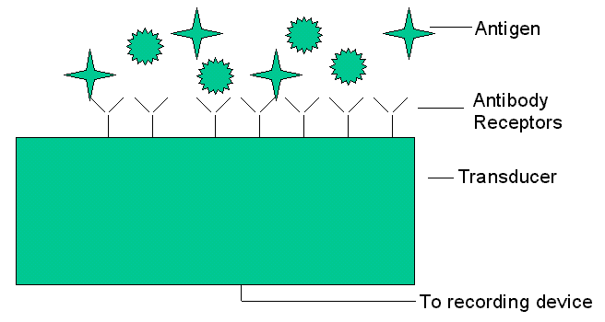
The detector which plays the role of transducer translates the physical or chemical change by recognizing the analyte and relaying it through an electrical signal.
Here the concept of shape specific recognition is commonly used to explain the sensitivity and selectivity of biological molecules especially antigen-antibody systems. Suppose an antigen is detected by the antibody receptors, a voltage is generated through the transducer which goes to the recording device. The voltage generated is due to the change in mass on the crystal layer that is created due to the change in mechanical pressure. The recording device used here is one of the pair of QN902X wireless Bluetooth (master and slave). It already has Nano-ADC inside it, so the voltage generated will be converted into digital data. That data is sent serially to the other Bluetooth pair which is situated outside the body. The outer Bluetooth is connected to a Raspberry-pie hardware. With the help of this hardware, data can be sent to a cloud server by establishing an Ethernet connection. The data will be stored on cloud server with the help of database methods such as apache, SQL and many others. Now the data from cloud server will be transferred to data analyzer. We have used Raspberry-pie hardware as a data analyzer. It will compare the data with the data of a healthy person and push an alert into a user device if M.TB bacteria are detected.
Scope:
In the present scenario, once the symptom is observed in the patient, the sample is sent for diagnosis (which may take 4–8 weeks). In our case as soon as the anti-body is detected, alert is raised, before even the symptom is seen.
The piezoelectric quartz sensor and the bluetooth pair (QN902X) come at a nominal cost within 350-400 Rs. However for very low income areas, the Government may organize camps to arrange for the devices at more subsidized rates.
Again the cloud will contain a complete data of all the users which will help the health department to recognize the affected areas and make a comprehensive analysis.
One chief concern of the users maybe that biochip being a foreign element may have any side effects or may not be suitable to all body types & may cause allergy in some. But it has been tested that they are safe for all body types.

Diagram / Pictures (if any):
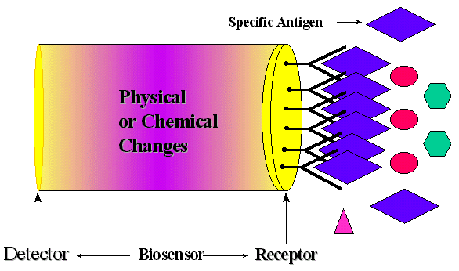
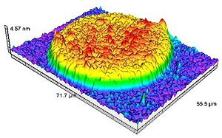
3D Surface image of a biochip
References:
http://www.who.int/tb/publications/global_report/gtbr2016_executive_summary.pdf
https://link.springer.com/article/10.1007%2Fs00216-008-2591-x
http://pubs.acs.org/doi/abs/10.1021/ac50021a007
http://www.nxp.com/documents/data_sheet/QN902X.pdf
Hussain, "Development and Applications of Piezoelectric Biosensors," M.S. thesis, University of South Alabama.

